Password Policy – Servers:
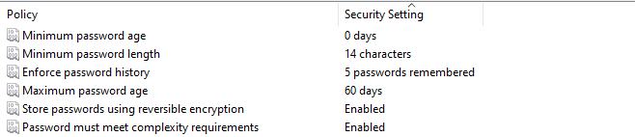

User Accounts – Only Trifour/Sautech User access:
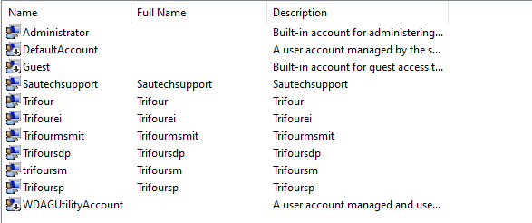

Admin Rights:
